Report 1

Women's Union of Al-Farabi
KazNU

"Promotion of women's rights and opportunities" round table conference

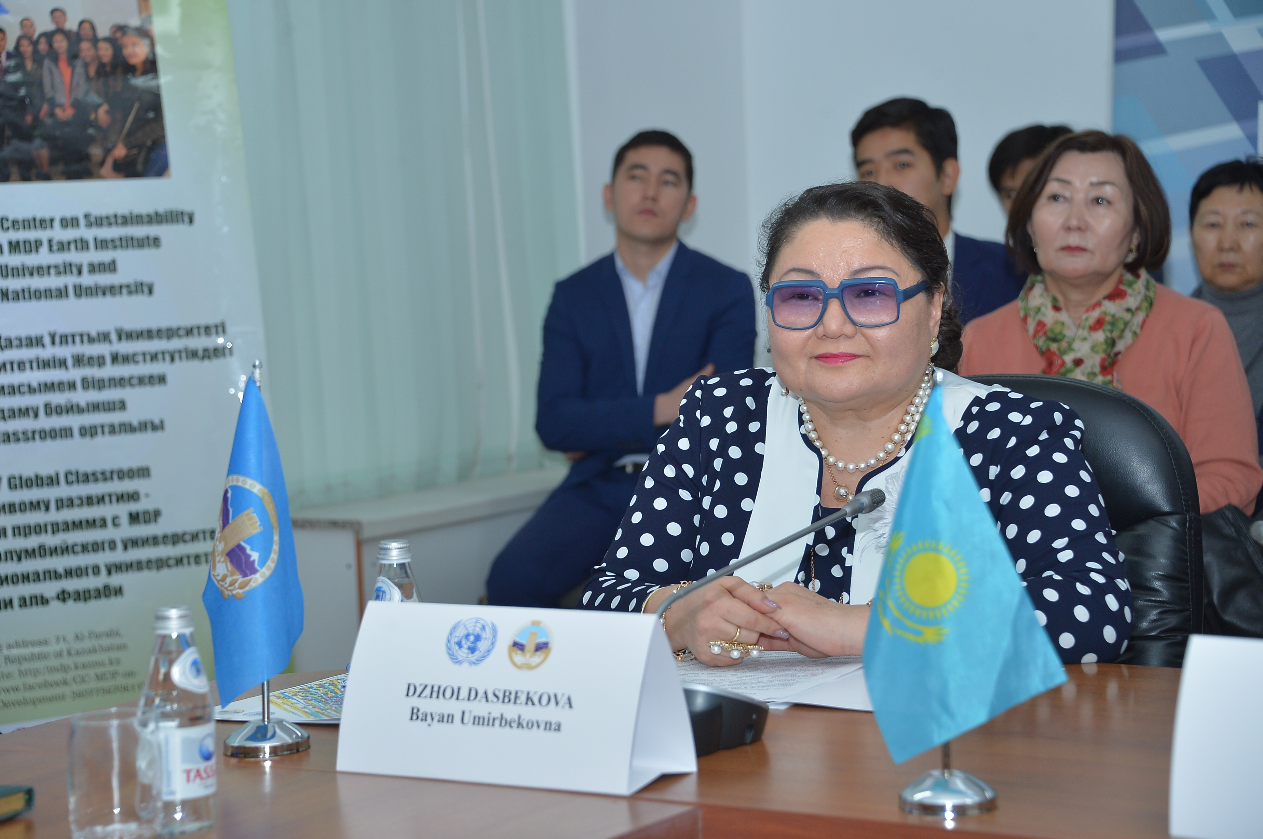

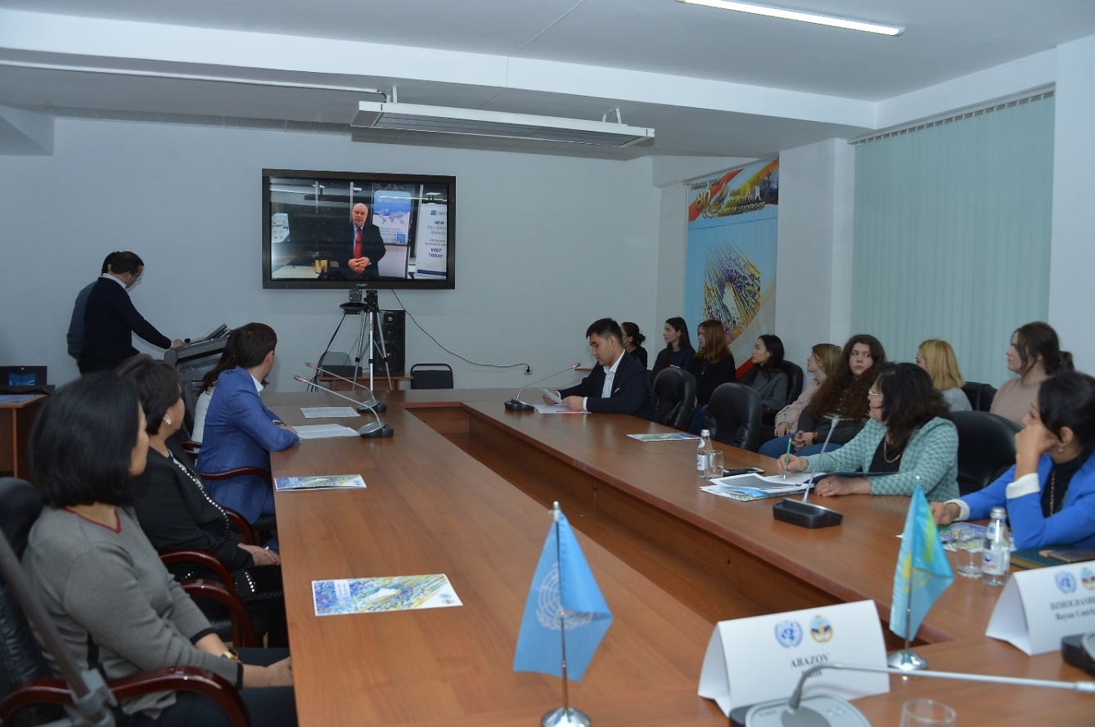

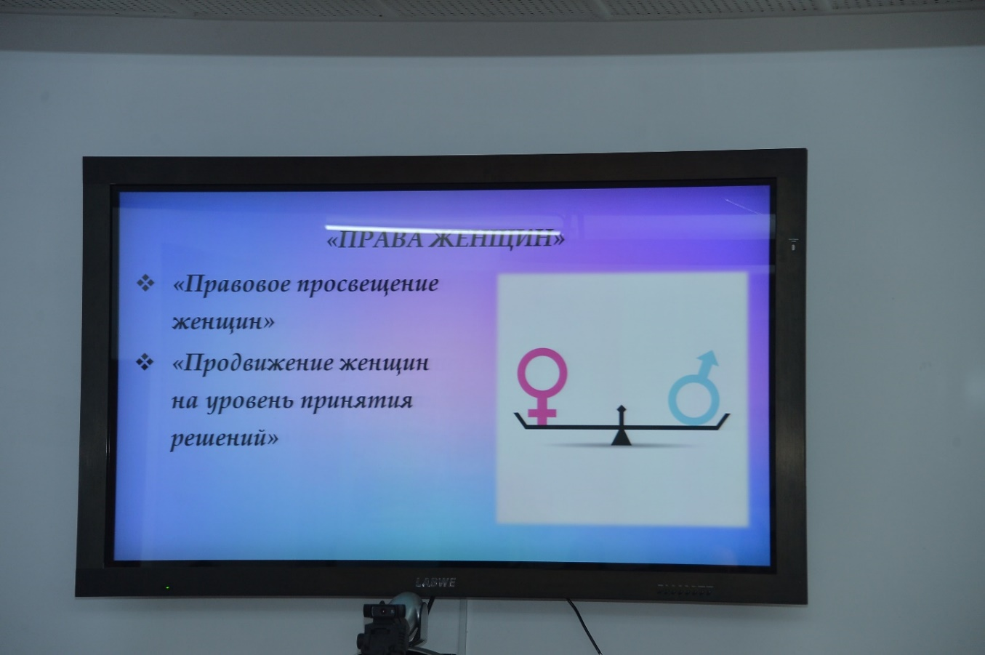

The round table was attended by students and staff of the university. The chairman of the organization Dr. Ph. Professor, Corresponding Member of the National Academy of Sciences of the Republic of Kazakhstan, Dean of the Philological Faculty Joldasbekova B.U. Philological Faculty Joldasbekova B.U., who briefly
told about the main tasks of promoting the rights and opportunities of women and ways of their realization by the Women's Union of KazNU. In Kazakh
National University named after Al-Farabi public organization - Women's Union of KazNU has been working for many years. Women's Union of KazNU
unites on a voluntary basis women's councils, unions, associations, committees and clubs operating in the university.
Main tasks of the Union
Women of KazNU:
- To promote the status of women in society, their role in life
KazNU
- Protection of women's rights
- Care about strengthening the family.
- Promotion of women at the level of decision-making.
For achievement of these tasks, the Union of women of KazNU offers to be oriented on the following criteria:
1. Family is the Basis of Everything
2. Ensuring Sustainable Development and Social Security
3. Women's Rights
4. Spirituality. Culture. Healthy Lifestyle
5. Best Practices. New Ideas. Affirmative Action

The teacher of the Department of Russian Philology and World Literature
Demchenko A.S. noted that by the first criterion it should be noted that in the center of attention of the Union of Women of KazNU is the family and its interests. The family is economic and social engine of society, the original educator of personality. Normal functioning of the family, its well-being and stability affects the state of society as a whole. Women's Union of KazNU believes that care about the family, its material and spiritual and moral well-being must be at the center of attention in the implementation of any policy, even those that have no direct connection with family problems, but the consequences of which may have a negative impact on the situation of the individual, affect the stable situation of the family, and, consequently, on the stable development of the university and the of the country as a whole. Within the framework of this subprogram we conduct actions: "Rights Family Rights", "Family Unity", "Relay Race of Maternal Feats" and others.
Doctoral student Shanaev R.U. expressed his opinion on the second criterion. He emphasized that sustainable development combines into one whole economic efficiency, social justice and environmental safety. The XXI century faced new challenges and new demands. The most important challenge to humanity is globalization, which, on the one hand, brings with it new challenges, political and economic changes that offer unprecedented opportunities for prosperity, on the one hand, and, on the other hand. It establishes economic,political and cultural domination of the stronger over the weaker.
In this process, not only is the gap between the haves and have-nots widening, but also the number of poor is increasing and the threat of poverty is growing. Not only does it widen the gap between the haves and have-nots, but it also increases the number of the poor and threatens civil society.The effects of globalization are particularly hard suffer the most vulnerable layers of society: the elderly, women and children. In this context, the Women's Union of KazNU proposes to continue to participate in the realization of priority government projects and also to realize the following actions: solidarity action "I am strong", "New technologies - new opportunities" and others.
Student Myrzabekov Damir made a report on the third criterion, which states about women's rights. All human rights - civil, cultural, economic, political and social, including the right to development - are comprehensive, indivisible and interdependent, interrelated and have essential for gender equality, development and peace in the twenty-first century.
We offer equal access, adequate representation and full participation of women in university governance structures at all levels. To achieve these goals, the Women's Union carries out the following projects and conducts campaigns: "Legal education of women", "Promotion of Women's legal education for women", "Promotion of women to the decision-making level", information and awareness-raising activities, etc.
Master's student Abiltaeva Dinara spoke about the fourth criterion: "Spirituality. Culture. Healthy lifestyle." Here it should be noted that moral culture of the society is the basis of a healthy lifestyle of the society in the present and future. Today society is increasingly ruled by soullessness, individualism, pragmatism and cynicism.
We must preserve honorably and proudly moral, spiritual integrity, to pass from generation to generation the sprouts of values guidelines. They are preserved in songs, bylines, legends, legends. The main keeper and transmitter of these values has always been and remains a woman. Women's Union of KazNU in the framework of the project "Ruhani zhangiru" organizes creative, literary evenings, meetings with poets and writers, concerts, as well as actions on healthy lifestyle: "Sport is a guarantee of longevity", "Women of KazNU", "Women of KazNU for a healthy lifestyle" and others.
Student Akhmet Ruslan noted that on the fifth criterion "Best practices. New ideas. Positive actions" provides for organizational strengthening of the Women's Union of KazNU, providing advisory and methodical assistance to all women of the university. At the end of the round table, students read poems about women and performed with musical acts.

